**Table structure**

**Table name: users**

| **FIELD** | **DATA TYPE** | **DESCRIPTION** |
| --- | --- | --- |
| id | varchar(16) | primary key |
| password_hash | varchar(128) | not null |
| Name | varchar(50) | not null |
| Department | varchar(15) | nullable |

**Table name: medicine**

| **FIELD** | **DATA TYPE** | **DESCRIPTION** |
| --- | --- | --- |
| id | int | primary key |
| name | varchar(100) | not null |
| dosage | number(6,2) | nullable |
| unit | varchar (5) | nullable |

**Table name: procedures**

| **FIELD** | **DATA TYPE** | **DESCRIPTION** |
| --- | --- | --- |
| id | int | Primary key |
| name | varchar (100) | not null |

**Table name: visits**

| **FIELD** | **DATA TYPE** | **DESCRIPTION** |
| --- | --- | --- |
| id | Int | primary key |
| doctor_id | varchar (16) | not null |
| patient_name | varchar (50) | not null |
| patient_age | int | not null |
| patient_gender | varchar (6) | not null |
| date | date | not null |

**Table name: prescription**

| **FIELD** | **DATA TYPE** | **DESCRIPTION** |
| --- | --- | --- |
| id | int | primary key |
| visit_id | int | not null |
| medicine_id | int | nullable |
| procedure_id | int | nullable |

**ER Diagram:**

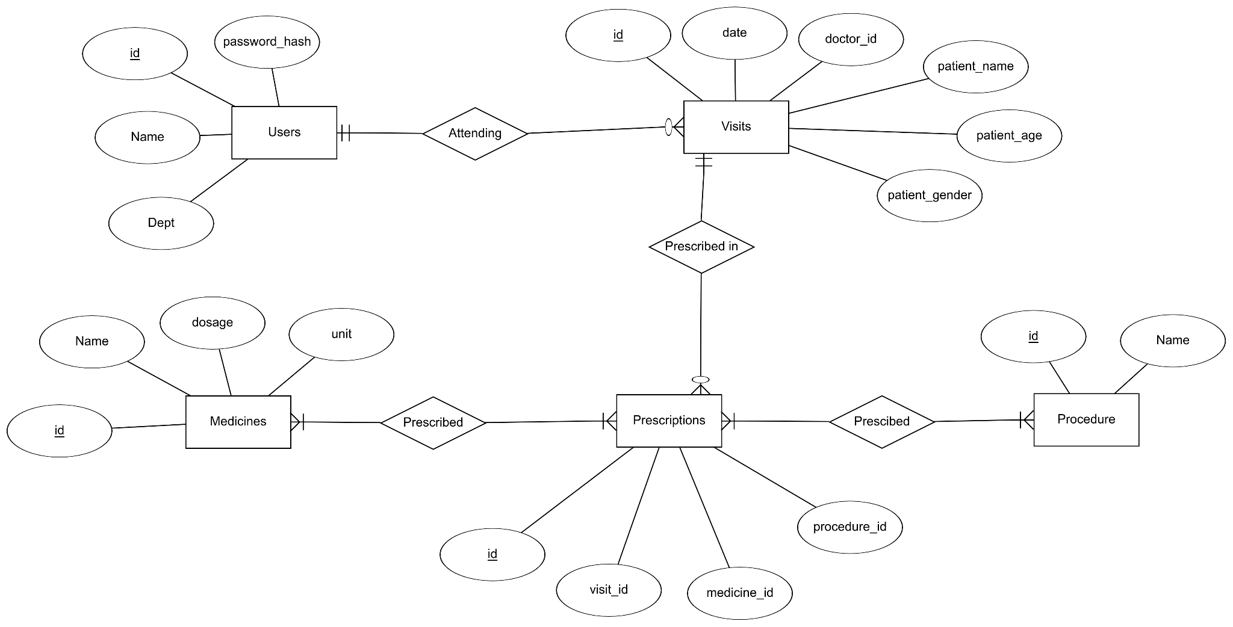

**Gantt Chart:**

